**WEEKLY PROGRESS REPORT ON**

**PREDICTING LIFE EXPECTANCY USING MACHINE LEARNING**

**BY**

**ASHISH KUMAR BARAI**

### Project Planning & Kickoff

### Project Scope, Schedule, Team & Deliverables

**Project Summary**

This project aims at predicting Life Expectancy rate of a country given various features.

**Project Requirements**

Python, IBM Cloud, IBM Watson

**Functional Requirements**

This project should be able to predict the Life expectancy considering various factors: Regional variations, Economic Circumstances, Sex Differences, Mental Illnesses, Physical Illnesses, Education, Year of their birth and other demographic factors.

**Technical Requirements**

Python and cloud

**Software Requirements**

Jupyter notebook

**Project Deliverables**

Working model of a project which predicts life expectancy

**Project Team**

Individually doing it

**Project Schedule**

Started on 6th May. This is one-month project

### Setup the Development Environment

Setup the Development Environment completed

Git Hub account created

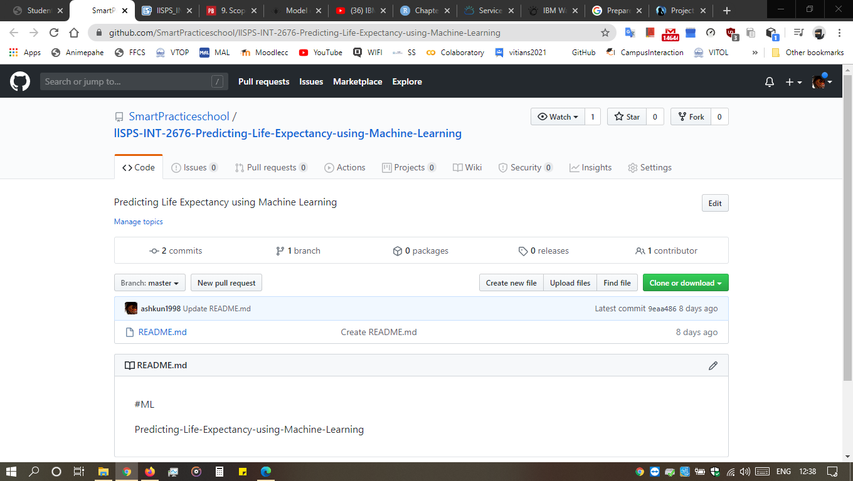

Slack Channel Joined and Writer logged in

**Explore IBM Cloud Platform**

Create IBM Cloud Account

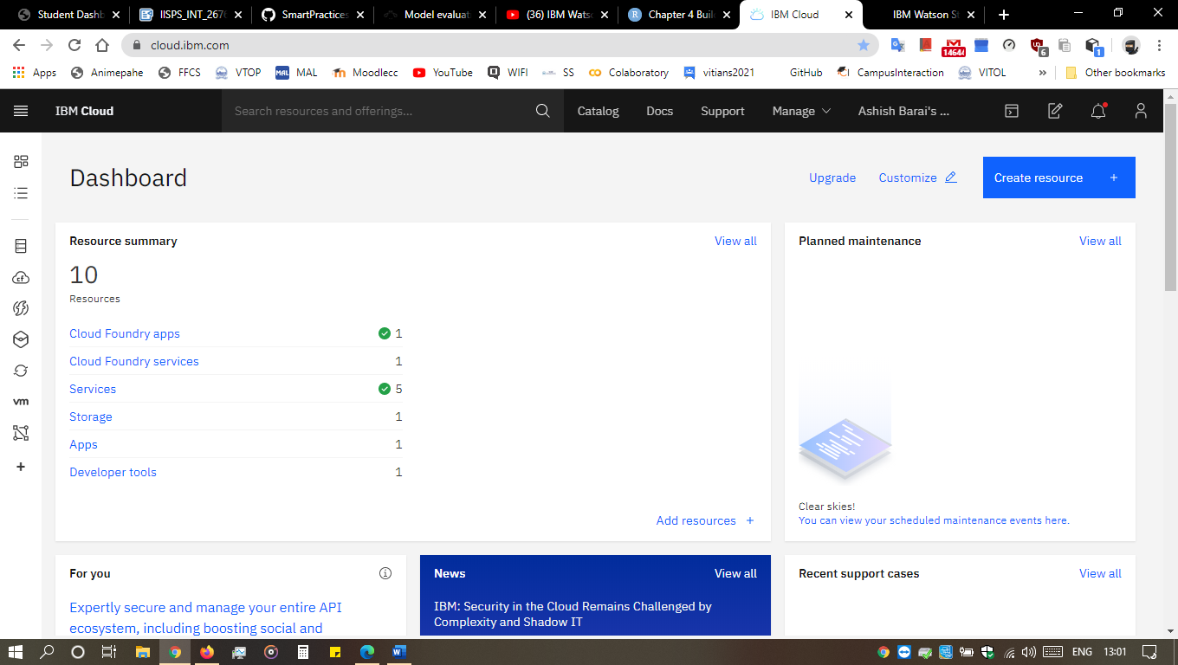

Create A Node-RED Starter Application

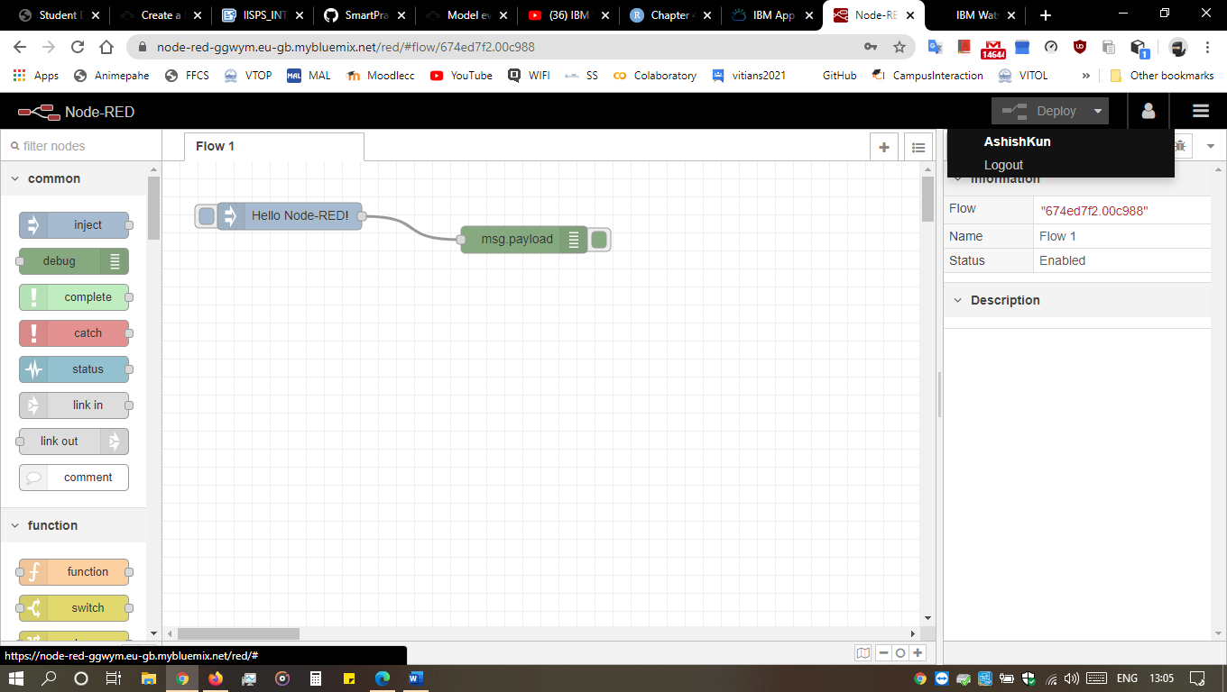

Create a simple Web Page

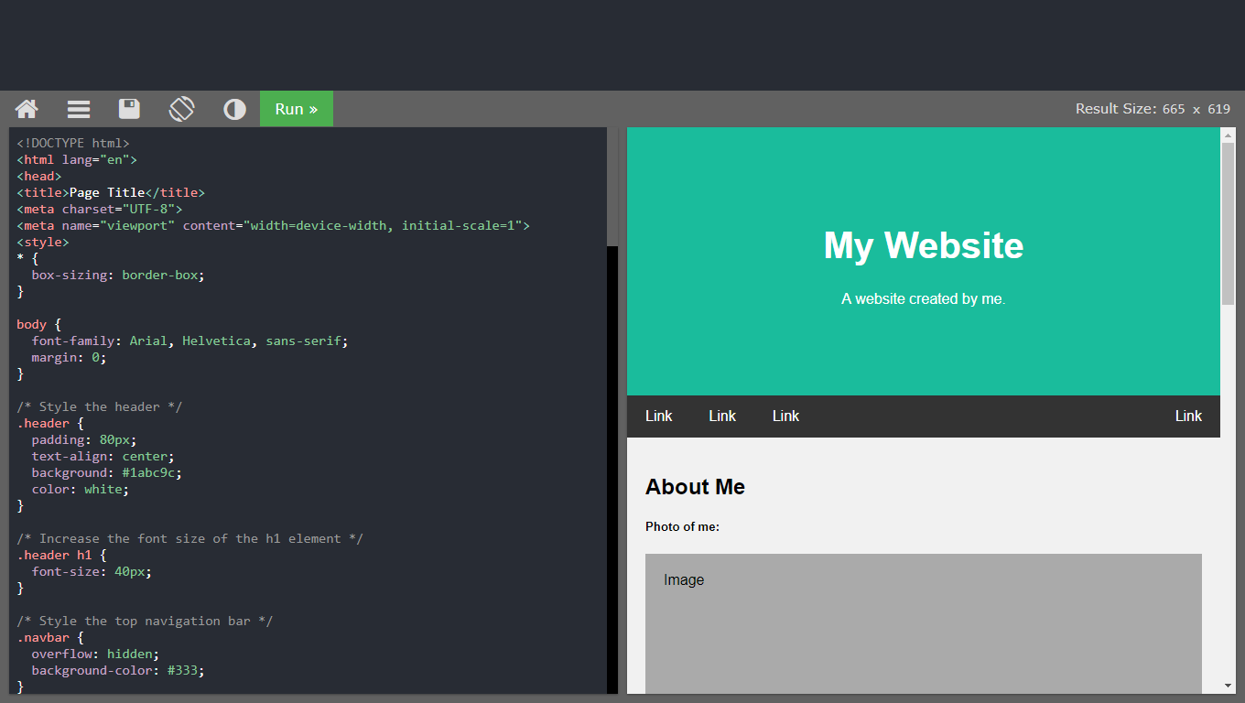

Creating an IBM account completed

Create A Node-RED Starter Application completed

**Explore IBM Watson Services**

**Explore IBM Watson Usecases**

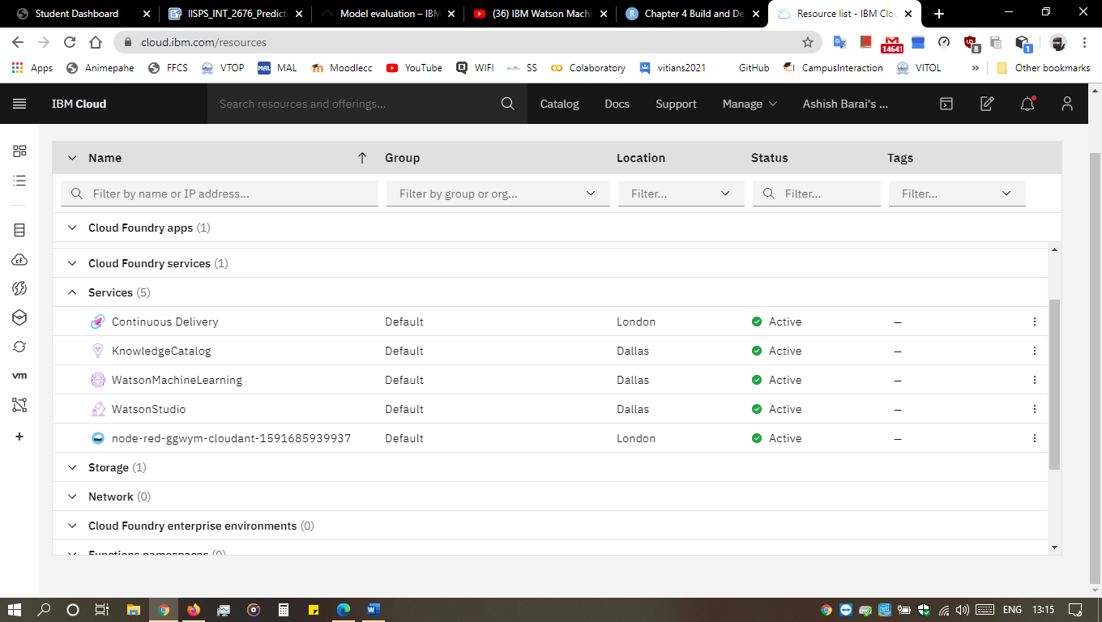

**Explore IBM Watson Machine Learning**

Did the 4 task assigned:

* 101 Build and test your first machine learning model using Python and scikit-learn
* 201 Learn regression algorithms using Python and scikit-learn
* 202 Learn classification algorithms using Python and scikit-learn
* 203 Learn clustering algorithms using Python and scikit-learn

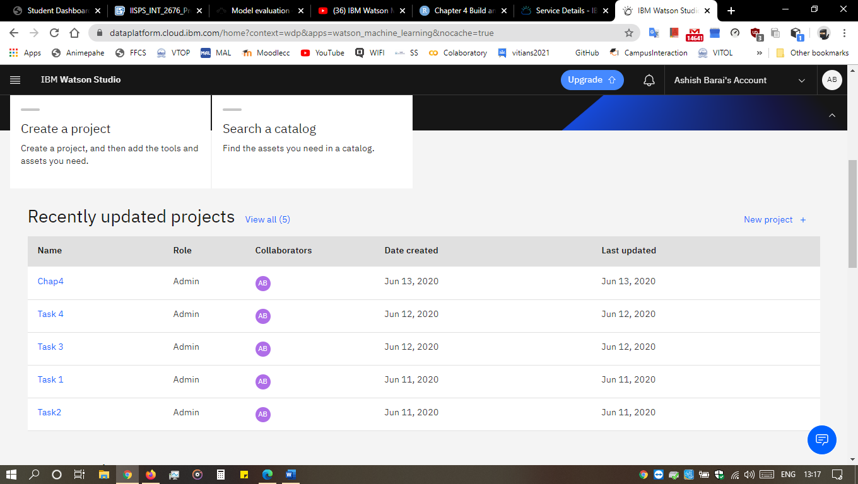

**Introduction to Watson Studio**

**Build Your Own ML Model in IBM Watson Studio**

Unable to find this notebook WatsonsStudioWorkshop/02-Insurance Fraud Detection in Jupyter Notebook

**Automate Your ML Model**

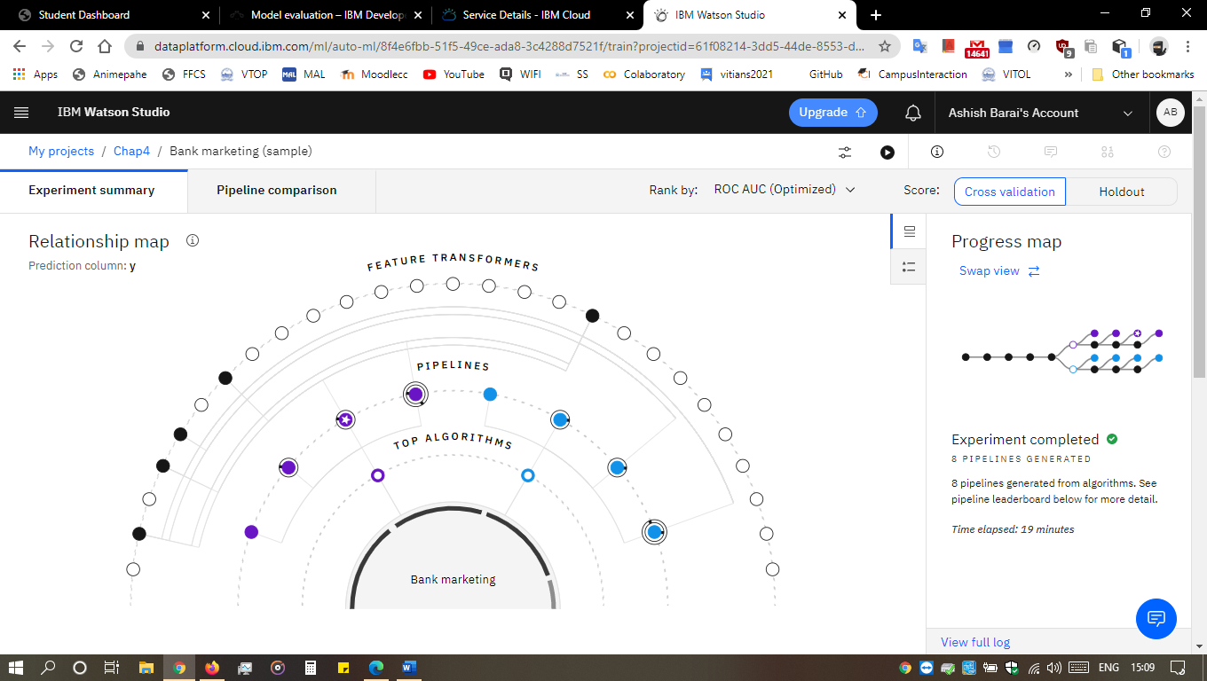

Build Your Own ML Model In IBM Watson Studio completed

**Predicting Life Expectancy With Python**

### Collect the Dataset for The Project

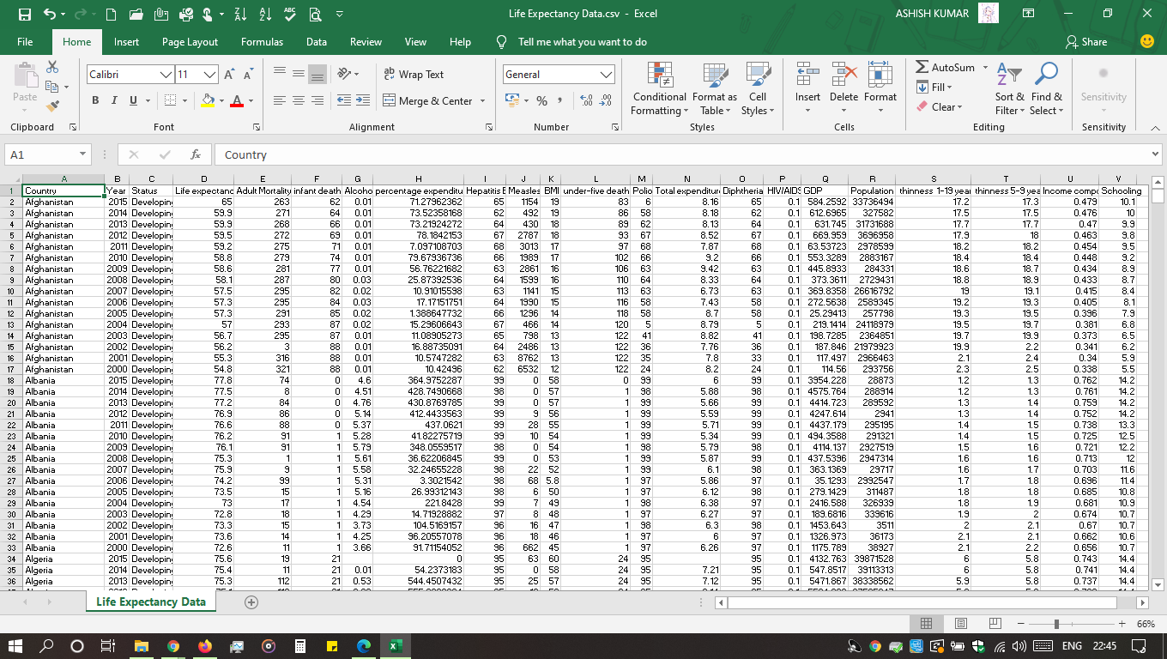

**Import Dataset into Jupyter Notebook**

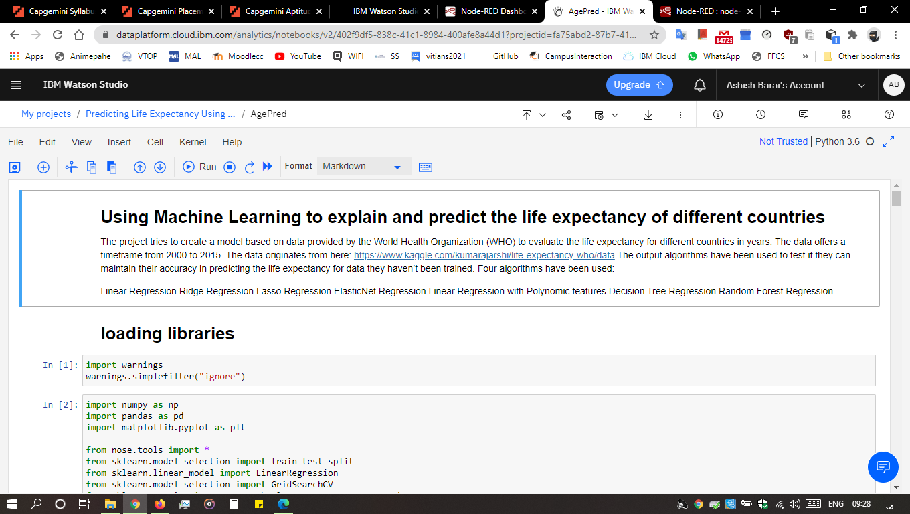

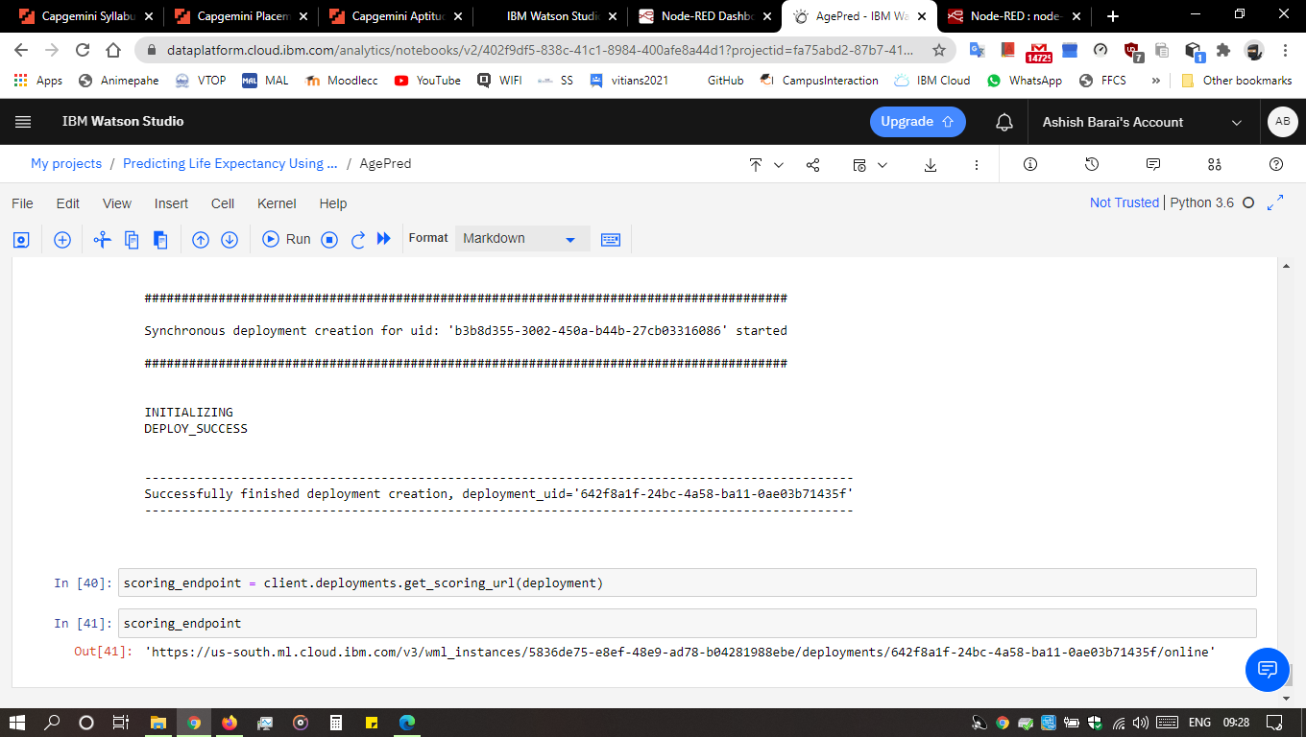

**Running AutoAI**

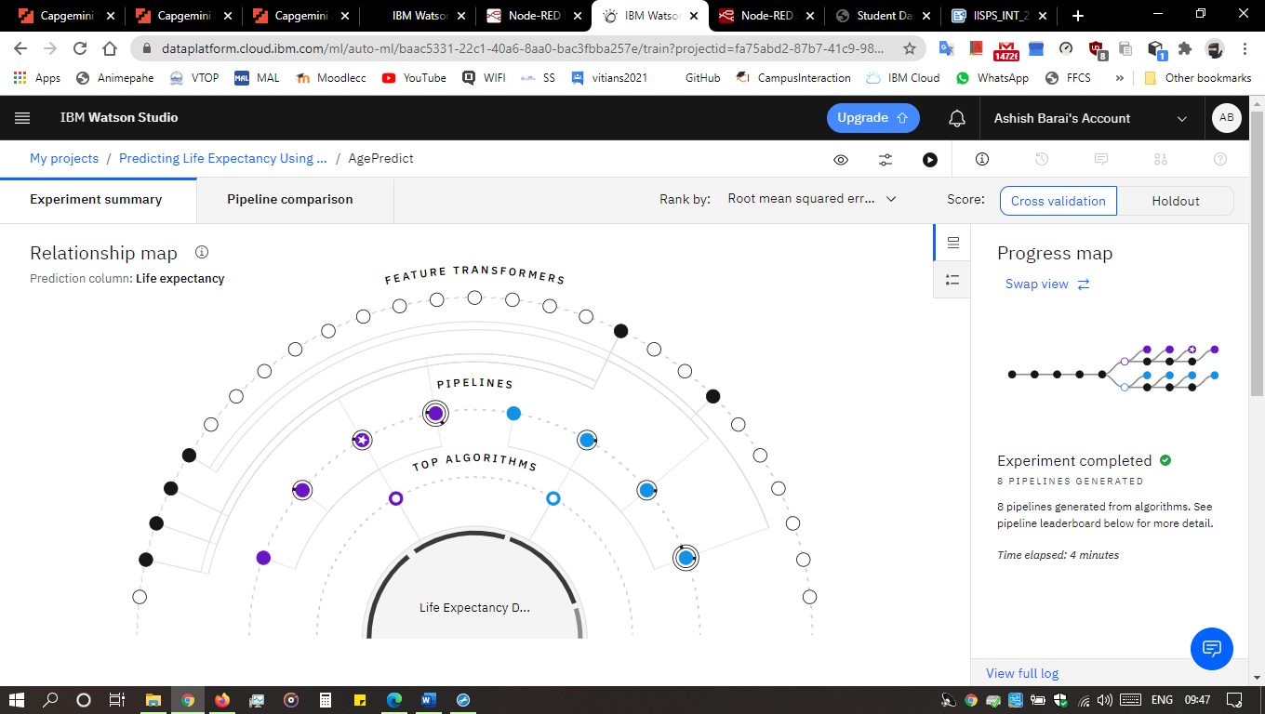

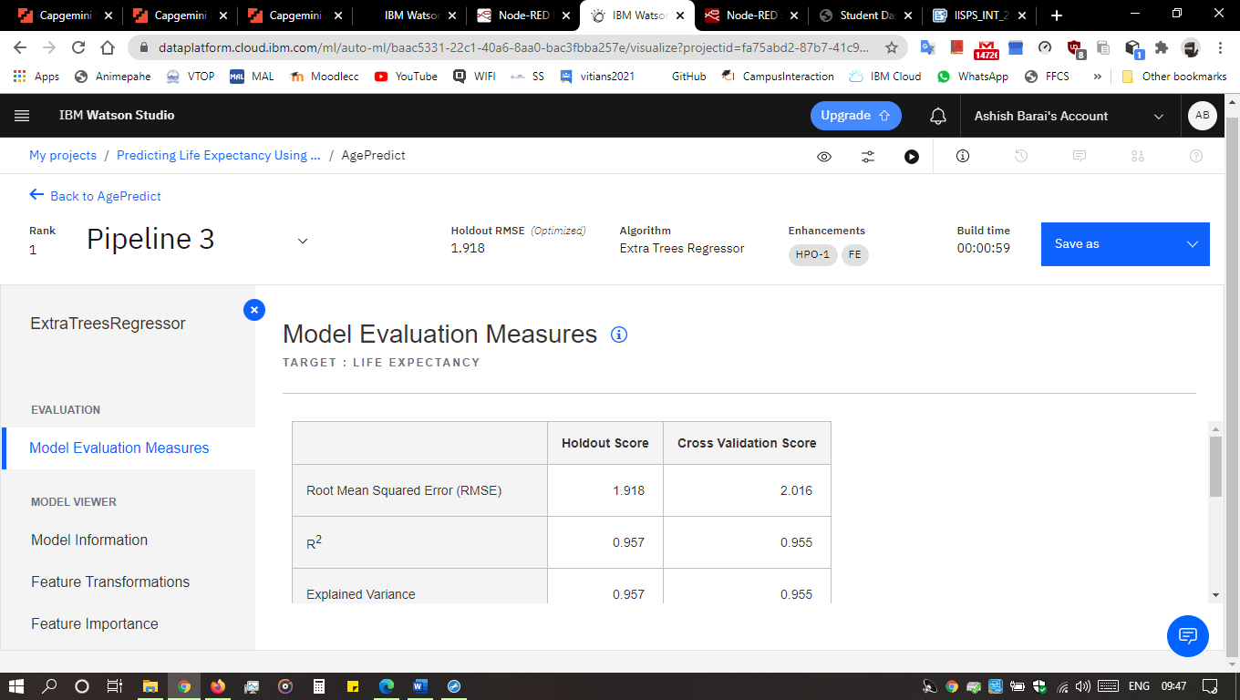

**Building Node-Red flow to integrate ML services**

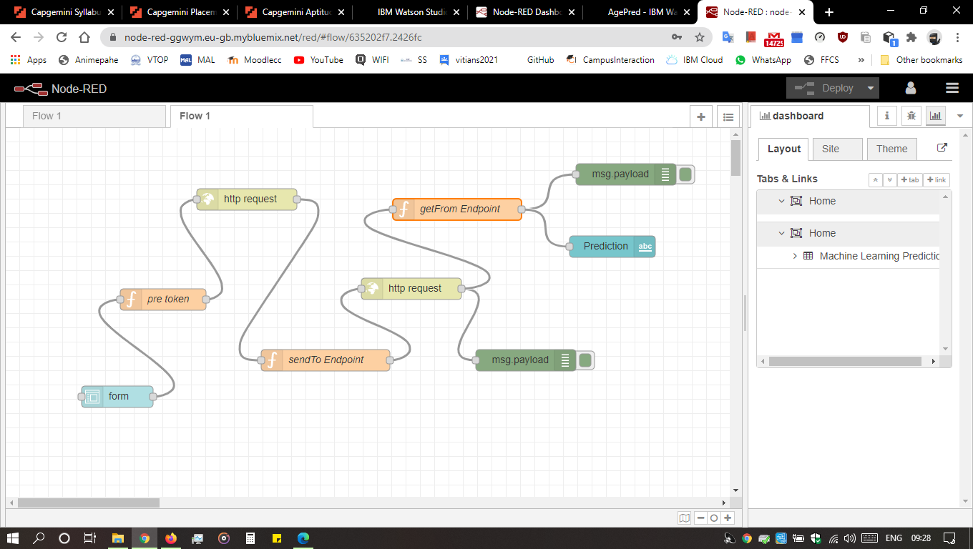

**Result**

